**IR sensor report**

There are 4 stages in the IR detecting circuit:

1) Receiving signal;

2) Amplifying;

3) High pass filter;

4) Schmitt trigger;

To receive the signal, an infrared diode was connected in series with a resistor. When infrared light was emitted towards the diode, its resistance would decrease, causing an increase in the voltage across the resistor.

In the amplification stage, an inverting amplifier with a gain value of 1000 was used to amplify the signal. However, the actual gain would not exceed 40 as the output voltage had to stay in the range 0-5V. A capacitor was added between the first and second stages to block the input voltage from the 2.5 DC bias. The signal had frequencies 353 Hz and 571 Hz, so a chip LT1366 (from autumn term) was used, providing a gain bandwidth product of 400 kHz.

However, the amplified signal was still unstable, which was uneasy to set the bias value for the Schmitt trigger. In order to block any noise, a high pass filter was added. After that, the signal could be converted to a square wave using a Schmitt trigger, which was biased at 2 volts.

The following is the sketch of circuit and a screenshot of the signal input for the microcontroller:

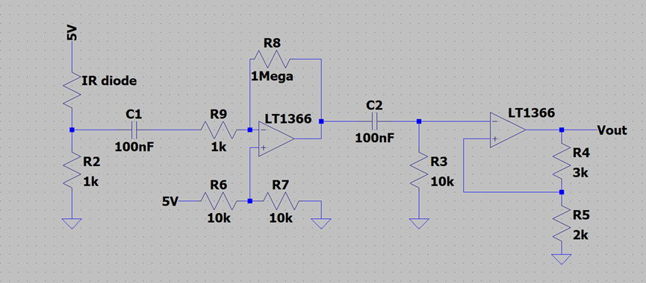

Figure x: circuit diagram of the IR sensor

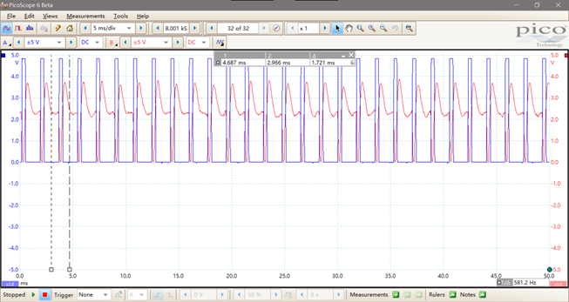

Figure x: a screenshot of picoscope (red: signal output from filter; blue: signal output from schmitt trigger)

The output signal was then sent to the microcontroller that counted frequency per unit time.

(not sure if this following part goes into improvements)

When testing the sensor with Metro M0 boards, it was noticed that the input pins have built-in diodes which would only allow current under () to get through. In order to make sure that the input signal would have a proper magnitude which could be received by Arduino, an additional 10k resistor was added to the output side, as shown below:

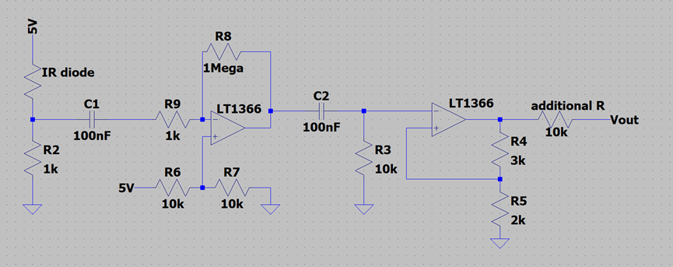

Figure x: circuit diagram with the additional resister

Decoupling capacitors were also added into our circuit to get rid of the noise coming from the Metro board.